# Web 3 Practical– Responsive Web Design

1. On the I: drive you will find two files called index.html and style.css. If you open index.html in the browser you will see something similar to:

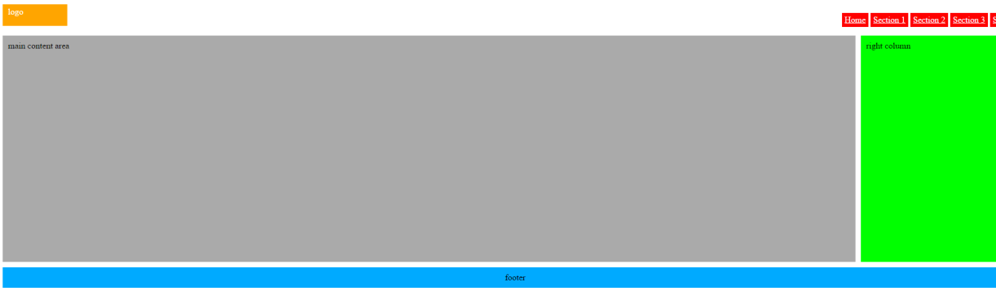

The objective of today’s practical is for you to modifiy the style.css file in order to get the following look for a small screen size device:

